Install the Raspberry Pi system

## Required tools:

1. Sd card
2. Card reader

## Download Raspberry Pi System

Raspberry Pi image file download address: <https://www.raspberrypi.org/downloads/raspbian/>

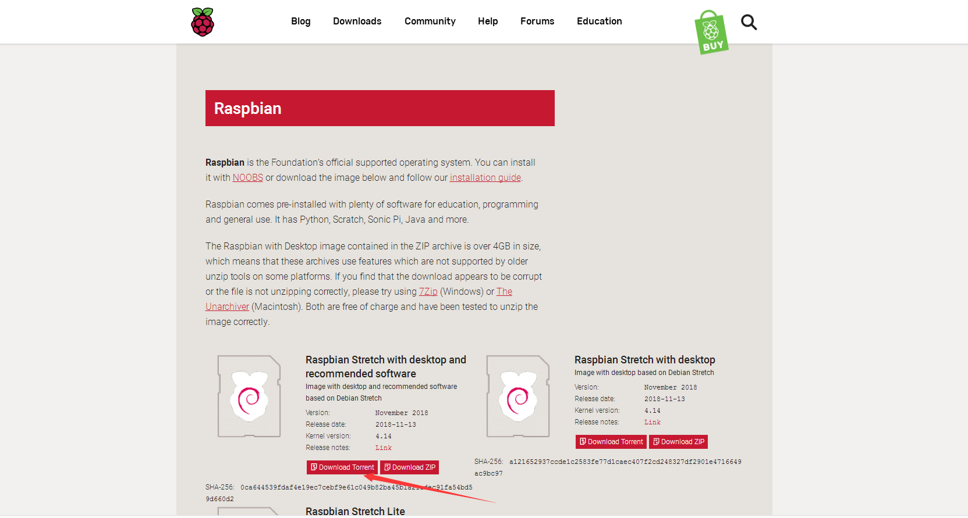

Unzip after downloading

## Install Win32DiskImager

Win32DiskImager download address:

<https://sourceforge.net/projects/win32diskimager/>

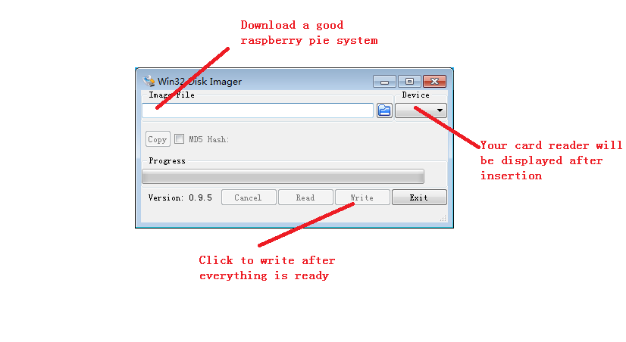

Please be patient and the tutorial ends here.